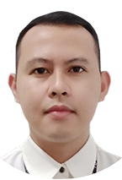

**Mechilina, Mark Russel A.**

**SBM Technician (1 Year & 9 months)**

**Alpla Philippines Inc.**

(+63) 909 852 8886 | [mackymechilina@gmail.com](mailto:mackymechilina@gmail.com)

**Experience**

Aug. 2017 – May 2019 **SBM Technician**

**Alpla Philippines Inc.**

Silangan Industrial Estate, Canlubang, Calamba City, Laguna

* Responsible for Operating and tending machines needed in manufacturing PET bottles following well-established standard operating procedures.
* Able to perform all operations in the Stretch Blow Molding process including in-line quality.

Aug. 2015 – Aug. 2017 **Production Operator**

**Delta Design Philippines LLC**

C4, 5A, Carmelray Industrial Park II, Brgy. Milagrosa, Calamba City, Laguna

* Operating a Laser Cutting machine to produce contactor parts of test handling machines.
* Troubleshooting and repairing machine errors and conduct daily machine inspections before mass production.
* Perform soldermasking for parts that needs soldermask coating, bending parts using Pneumatic Bending Machine.

Sep. 2014 – Aug. 2015 **Deburring Helper**

**Pipols Synergy Management Services Inc.**

**(Under Delta Design Philippines LLC)**

C4, 5A, Carmelray Industrial Park II, Brgy. Milagrosa, Calamba City, Laguna

* Deburring and breaking excess parts of finished materials (spares and kits) after machining.
* We also perform other duties like tapping, ID marking, cleaning, sandblasting, sanding and buffing of materials to make a good quality product ready for plating, assembling, and packaging.

Feb. 2013 – Sep. 2013 **Material Handler**

**JECO Autoparts Philippines Inc.**

122 Excellence Avenue cor Quality Drive SEPZ 1, Carmelray Industrial Park I, Canlubang, Calamba City, Laguna

* Handler and supplier of electronic parts (such as: lead-free PCB’s, IC’s, chip diodes, chip resistors, chip transistors, coils, switch, connectors, mold parts) to SMT machines and production lines.

Jun. 2011 – Dec. 2011 **Operator / Inspector**

**Gotoh Philippines Corporation**

Lot 16, Rd. 3, Phase II-B, SEPZ1, Carmelray Industrial Park I, Canlubang, Calamba City, Laguna

* Operating Stripe-Plating Machine
* Inspecting and measuring thickness of Stripe-Plated Leadframes (Silver-Plated, Nickel-Plated)

Sep. 2010 – Feb. 2011 **Storekeeper**

**Tong Hsing Electronics Philippines Inc.**

Plant 2, 103 Prosperity Avenue, Carmelray International Business Park I, Canlubang, Calamba City, Laguna

* Handler of tools and equipment such as: electrical and industrial tools and parts. Also a handler of janitorial consumables and materials.
* We also conduct a monthly inventory of incoming and outgoing materials that we’ve purchased.

Jan. 2010 – Jun. 2010 **Boxer & Material Handler**

**Advanced Molding Company Inc.**

#5 Circuit St., LISP 1, Cabuyao, Laguna

* Packaging all finished goods into a box for shipping.
* Handler and supplier of consumables and raw materials to production lines.

Mar. 2008 – Aug. 2009 **Electronics Assembler**

**Shindengen Philippines Inc.**

120 Excellence Avenue corner Quality Drive, SEPZ, Carmelray Industrial Park I, Canlubang, Calamba City, Laguna

* Operating a Molding Machine, to form / to mold a leadframe into a diode.
* Operating a Deflashing Machine which removes excess flashes of molded diodes from Molding Process.

**Education**

**Tertiary**

2019 up to present  **Saint Vincent College of Cabuyao**

Mamatid Road, Cabuyao, Laguna

**(Bachelor of Science in Information Technology)**

**Vocational**

2012 **Calamba Manpower Development Center**

Old Cooperative Building, Calamba City, Laguna

**(Consumer Electronics Servicing)**

**Secondary**

2006 **Liceo de Calamba**

422 Burgos St., Calamba City, Laguna

**Primary**

2002 **Parian Elementary School**

Manila S Rd., Calamba City, Laguna

**About Me**

Gender Male

Birthdate September 11, 1989

Birthplace Villa Silangan, Calamba City, Laguna

Age 32 years old

Address Purok 7A PNR Site, Brgy. Uno, Calamba City, Laguna

Nationality Filipino

Status Married

Height 5’6”

Weight 75 kgs.

Email Address [mackymechilina@gmail.com](mailto:mackymechilina@gmail.com)

Contact Number (+63) 909 852 8886

*I hereby certify that all the above information was true and correct, with the best of my knowledge and belief.*

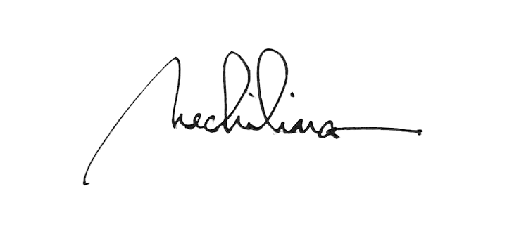

Mark Russel A. Mechilina